



Minutes

**SONIA Stakeholder Advisory Group**

26 February 2020

**Location:** Bank of England

### Minute no.

**Minute**

1. **Review of market conditions**

The Bank presented a pack of publically available statistics on SONIA rate and volumes, and on the adoption of SONIA referencing products.1

The SONIA rate continued to be stable, increasing slightly since the September meeting of the Group, with the basis to Bank Rate consistently around 4 basis points for the previous 5 months. The market functioned smoothly over year-end, with the SONIA rate barely moving, albeit on lower volumes. This was consistent with the Members’ remarks at the previous meeting about the market’s preparations for the year-end. It was noted that volumes had taken longer to recover in January than in previous years. Members attributed this to some funds placing cash in Treasury Bills following issuance in the run up to year end; these needed to mature before cash returned to the SONIA market.

The Group discussed trading behaviour on the MPC announcement days, in particular when there was uncertainty on the outcome of the decision.

The Group noted the UK’s withdrawal from the EU on 31 January had no impact on market functioning. Subject to the outcome of talks during 2020, this was unlikely to be a focus for the SONIA market until year-end when the transition period ended.

### Update on the transition to SONIA from £LIBOR

The Bank provided an overview of the announcements made on 16 January 2020 by the Working Group on Sterling Risk-Free Reference Rates (RFRWG), Bank of England and Financial Conduct Authority (FCA). These covered a range of issues, outlining priorities and milestones for 2020 on LIBOR transition: "*Next steps for LIBOR transition in 2020: the time to act is now*".2 A key milestone was the RFRWG’s target to cease, by end-Q3 2020, the issuance of sterling LIBOR-based cash products maturing beyond 2021.

The Bank also provided an overview of the announcement that morning of its intention to produce a SONIA Compounded Index and the possibility of producing SONIA Period Averages: *Supporting Risk-Free Rate transition through the provision of compounded SONIA*.3

The Group was very supportive of the proposed compounded index. Several members felt the utility of the index, and the inherent tradeoffs involved in using period averages meant they did not see an immediate role for the production of period averages. The Bank encouraged all to respond to the consultation.

1 Appended to these minutes.

2 [www.bankofengland.co.uk/news/2020/january/next-steps-for-libor-transition-in-2020-the-time-to-act-is-now](http://www.bankofengland.co.uk/news/2020/january/next-steps-for-libor-transition-in-2020-the-time-to-act-is-now)

3 [www.bankofengland.co.uk/paper/2020/supporting-risk-free-rate-transition-through-the-provision-of-compounded-sonia](http://www.bankofengland.co.uk/paper/2020/supporting-risk-free-rate-transition-through-the-provision-of-compounded-sonia)

### The evolving uses of SONIA

The market of SONIA referencing loans had been growing slowly, although the RFRWG Q3 target for ceasing to issue LIBOR referencing products had focused minds. The Bank’s announcement on producing a compounded index was seen as very helpful by simplifying the calculation of rates payable in contracts and by encapsulating a number of conventions.

It was discussed that the £FRN market had been considering on whether a change in the conventions adopted to provide a degree of payment certainty should be changed. The convention had been to use an ‘observational lag’, but a recent issuance had adopted an ‘observational shift’. It was noted that the Bank’s proposed SONIA Compounded Index was compatible with the observational shift methodology.

A Member noted that the SONIA referencing CD market was growing very slowly, in part through a lack of agreement on the appropriate conventions to adopt. It was agreed the RFRWG’s bonds sub group should consider this question.

### A discussion of implications for participants in the underlying overnight unsecured deposit market of increased use of SONIA

As the market for products referencing SONIA increased, participants in the sterling overnight unsecured market would increasingly also be offering products that reference SONIA. The SONIA reporters understand the need to have robust systems and conduct controls in place.

The Bank noted that all reporters to Form SMMD, a subset of which was used as input data in the SONIA calculation methodology, were required to meet all aspects of the Form SMMD Reporting Instructions which set out technical requirements for reporting as well as controls required. Two Senior Managers under the UK Senior Managers Regime attested to their firm’s compliance with these instructions on an annual basis.

The Bank had discussed also this issue with the FCA, as the conduct regulator, who had provided the following view.

*The FCA see this circumstance as not different to other situations where a firm is a significant participant in a market that is measured by a benchmark and also has financial exposure to that benchmark. Examples include:*

* + *Libor*
  + *ICE Swap Rate where traders can trade in the underlying swaps and in the referenced swaptions.*

*The FCA they believe that in such scenarios they would expect banks to have a robust control framework in place which identifies the potential conflicts of interest at trader, desk and firm level and implements controls to mitigate the risks.*

*Such controls could include:*

* + *Physical segregation between desks and individuals who transact in sterling money market transactions and those who use SONIA in their contracts*
  + *Communications surveillance between individuals who have been identified as having conflicts of interest*
  + *Transaction monitoring to identify trading behaviour which may indicate misconduct*
  + *Implementation of remuneration policies which do not incentivise misconduct*

*The mitigating controls should be proportionate to the risks identified and subject to the appropriate level of governance and oversight.*

### Future discussion topics

The Group expressed interest in the Bank providing further updates on the transition away from

£LIBOR at future meetings, including the work of the Tough Legacy Task Force.

### AOB

The Bank noted this was Richard Moore’s final meeting as inaugural chair of the Group as his term on the SONIA Oversight Committee was ending. He was thanked for his work in establishing the smooth functioning of the group. This was endorsed by the members of the Group.

### Attendees:

Chair Richard Moore (Independent member of SONIA Oversight Committee) External Member Julia Black (Independent member of SONIA Oversight Committee) CurveGlobal Ian Murphy

HSBC James Murphy Insight Investment Robert Gall ISDA Jonathan Martin

JP Morgan AM Olivia Maguire

LCH Philip Whitehurst

LGIM John Wherton

Mizuho Rob Thurlow RBC Capital Markets Sean Taor RBS Donal Quaid

Société Generalé Romain Sinclair Bank of England Will Parry

Tom Horn

Joanna McLafferty

**SONIA Stakeholder Advisory Group**

**February 2020**

## PUBLISHED SONIA STATISTICS

**Chart 1: SONIA volumes**

£Bns 60

50

40

30

20

10

0

Source: Bank of England

## Chart 2: SONIA rates and percentiles

25th - 75th percentiles 10th - 90th percentiles SONIA

Percent

0.80



0.75

0.70

0.65

0.60

Dec-18 Jan-19 Feb-19 Mar-19 Apr-19 May-19 Jun-19 Jul-19 Aug-19 Sep-19 Oct-19 Nov-19 Dec-19 Jan-20

Source: Bank of England

# USAGE OF SONIA

**Chart 3: SONIA Futures -monthly nominal volumes and open interest at month end\***

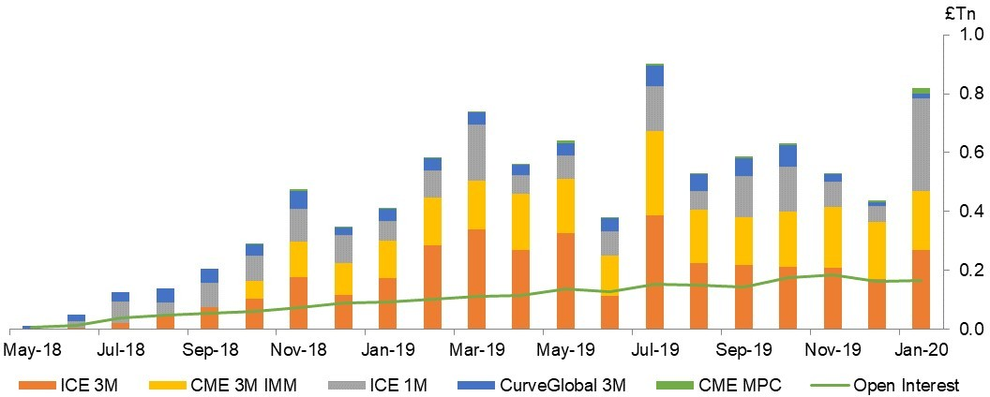

Source: ICE Futures, Curve Global and CME Group

* Lots traded multiplied by nominal lot size

# Chart 4: Volume distribution of FRN issuances

Source: Bloomberg L.P. and Bank of England Calculations

# Table 1: LCH Swap Statistics

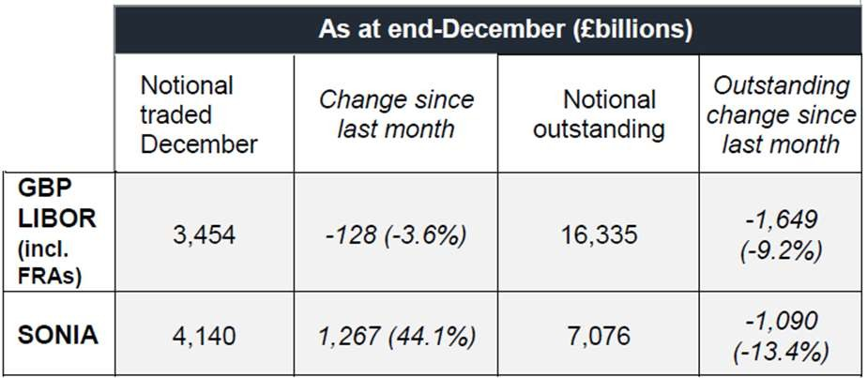

Source: LCH